7 Segment LED Interfacing to Arduino:

Introduction:
Segment displays are another common component in the world of electronics. These displays have 8 LEDs split into different segments designed to be able to display numerals from 0-9 and a dot. All The LEDs have a common ground / supply line. There are 5 pins at the top and 5 pins at the bottom. The middle pins in the top and bottom are connected to each other internally and have to be connected to Ground / Supply depending upon the type of the 7-segment Display. You can control each segment like an individual LED. However, this method of controlling the 7-segment LED to display numbers would be hectic. So, we will use a technique called Port Manipulation. Pins on the Arduino are grouped together as a PORT. You can control a whole PORT at a time.
Requirment:
- 7 segment display
- 1k Resistor
- Arduino Board
- Breadboard

Hardware configuration:
Segment & Pin Mapping of a 7-Segment LED as shown in given below. We will be connecting segments A-G & P to digital pins 0-6 & 7 of the Arduino.
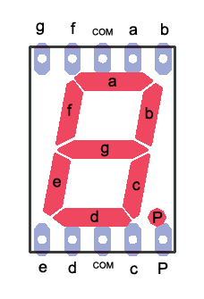

Step1:Place the 7-segment Displayon the Breadboard.
Step2:Place a 1K resistor between the middle pin on the top and the '-'ve terminal (com pin connected to -ve terminal)
Step3:Connect a Wire from Segment A to digital pin 0 of the Arduino
Step4:Connect a Wire from Segment B to digital pin 1 of the Arduino
Step5:Connect a Wire from Segment C to digital pin 2 of the Arduino
Step6:Connect a Wire from Segment D to digital pin 3 of the Arduino
Step7:Connect a Wire from Segment E to digital pin 4 of the Arduino
Step8:Connect a Wire from Segment F to digital pin 5 of the Arduino
Step9:Connect a Wire from Segment G to digital pin 6 of the Arduino
Step10:Connect a Wire from Segment P to digital pin 7 of the Arduino

This are all step requried to 7 segment LED interfacing to Arduino.

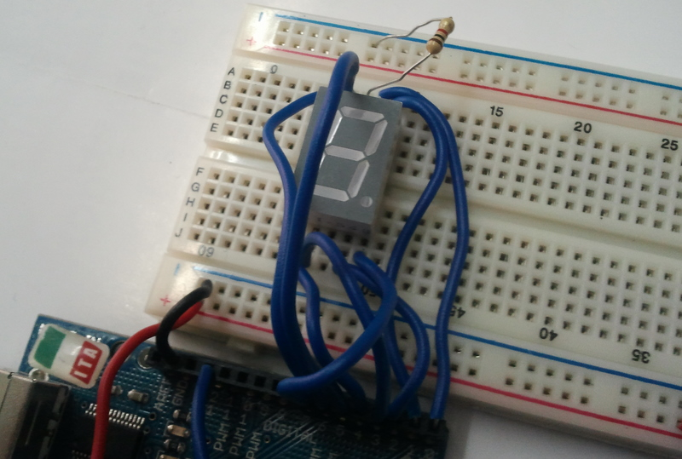
Our Final setup of 7 segment LED interface to Arduino as shown in below figure.

Programing:(source code)

Programming to control the 7 Segment LED:

/*

Thisis to Display numbers 0-9 on the seven segment LED

*/

/*

Wiring
Seg A – Pin 0
Seg B-Pin 1
Seg C-Pin 2
Seg D-Pin 3
Seg E-Pin 4
Seg F-Pin 5
Seg G-Pin 6
Seg H-Pin 7

*/

/*
To Display '0' we need to make high All Segments except G & H
based on this lets make list of values to write to port D [pins 0-7 are grouped together as port D]
When we write a binary value to the port the MSB or the 8th bit will be writtento pin 7 and the lsb will be written to pin0

0=>B00111111
1=>B00000110
2=>B01011011
3=>B01001111
4=>B01100110
5=>B01101101
6=>B01111101
7=>B00000111
8=>B01111111
9=>B01101111

*/

int val[]={B00111111,B00000110,B01011011,B01001111,B01100110, B01101101,B01111101, B00000111, B01111111, B01101111};

void setup()
{
DDRD=B11111111;
}

void loop()
{
for(int i=0; i<10;i++)
{

PORTD=val[i];
delay(1000);
}
}

/*

This is to Display numbers 0-9 on the seven segment LED based on Remote Control INPUT

*/

/*

Wiring
SegA-Pin0
SegB-Pin1
SegC-Pin2
SegD-Pin3
SegE-Pin4
SegF-Pin5
SegG-Pin6
SegH-Pin7

*/

/*
To Display '0' we need to make high All Segments except G & H
based on this lets make a list of values to write to port D [pins 0-7 are grouped together as port D]
When we write a binary value to the port the MSB or the 8th bit will be written to pin 7 and the lsb will be written to pin 0

0 => B00111111
1 => B00000110
2 => B01011011
3 => B01001111
4 => B01100110
5 => B01101101
6 => B01111101
7 => B00000111
8 => B01111111
9 => B01101111

*/

#include <IRremote.h>

int RECV_PIN = 12;
Irrecv irrecv(RECV_PIN);
decode_results results;
int remote = 0, display_value=0;

int val[]={B00111111,B00000110,B01011011,B01001111,B01100110, B01101101,B01111101, B00000111, B01111111, B01101111};

void setup()
{
DDRD=B11111111; // Declares PORT D as Output, PORTD is digital pins 0-7
irrecv.enableIRIn();// Start the receiver
}

void loop()
{
if (irrecv.decode(&results)) {
remote=results.value;
switch(remote)
{
case 16 : display_value=1; break;
case 2064 : display_value=2; break;
case 1040 : display_value=3; break;
case 3088 : display_value=4; break;
case 528 : display_value=5; break;
case 2576 : display_value=6; break;
case 2960 : display_value=7; break;
case 3600 : display_value=8; break;
case 272 : display_value=9; break;
case 2320 : display_value=0; break;
}

PORTD=val[display_value];
irrecv.resume();// Receive the next value

}
}
Installation:
The source code copy to the skeches of arduino and compile (there is verify option) as shown given below.
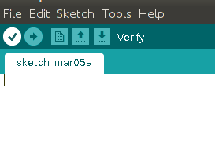

And then uploding the source code.(there is uploding option) to the Arduino board.(software) as shown given below.
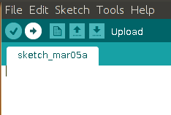

Troubleshooting:
FAQ:
Maintainers:
Duryodhan Aldar (durva.ges@gmail.com)

References: http://quickstartkitforarduino.blogspot.in/

